*Student: Melis Kilic*

**Binarization**

**Bin-1. Binarization based on histogram**

coins_image = imread('coins.png');

% Display

figure;

subplot(2, 2, 1);

imshow(coins_image);

title('Original Image');

subplot(2, 2, 2);

imhist(coins_image);

title('Histogram');

threshold = 120;

binary_coins = imbinarize(coins_image, threshold / 255);

subplot(2, 2, 3);

imshow(binary_coins);

title('Binary Image');

shape1_image = imread('shape1.png');

shape2_image = imread('shape2.png');

shape3_image = imread('shape3.png');

% Display

figure;

images = {shape1_image, shape2_image, shape3_image};

for i = 1:3

subplot(3, 4, (i - 1) * 4 + 1);

imshow(images{i});

title(['Shape ' num2str(i)]);

subplot(3, 4, (i - 1) * 4 + 2);

imhist(images{i});

title('Histogram');

threshold = 120;

binary_shape = imbinarize(images{i}, threshold / 255);

subplot(3, 4, (i - 1) * 4 + 3);

imshow(binary_shape);

title('Binary Image');

end

**Result of the code:**

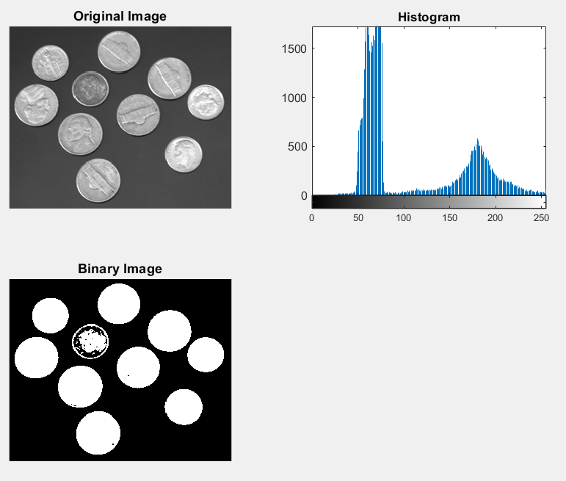

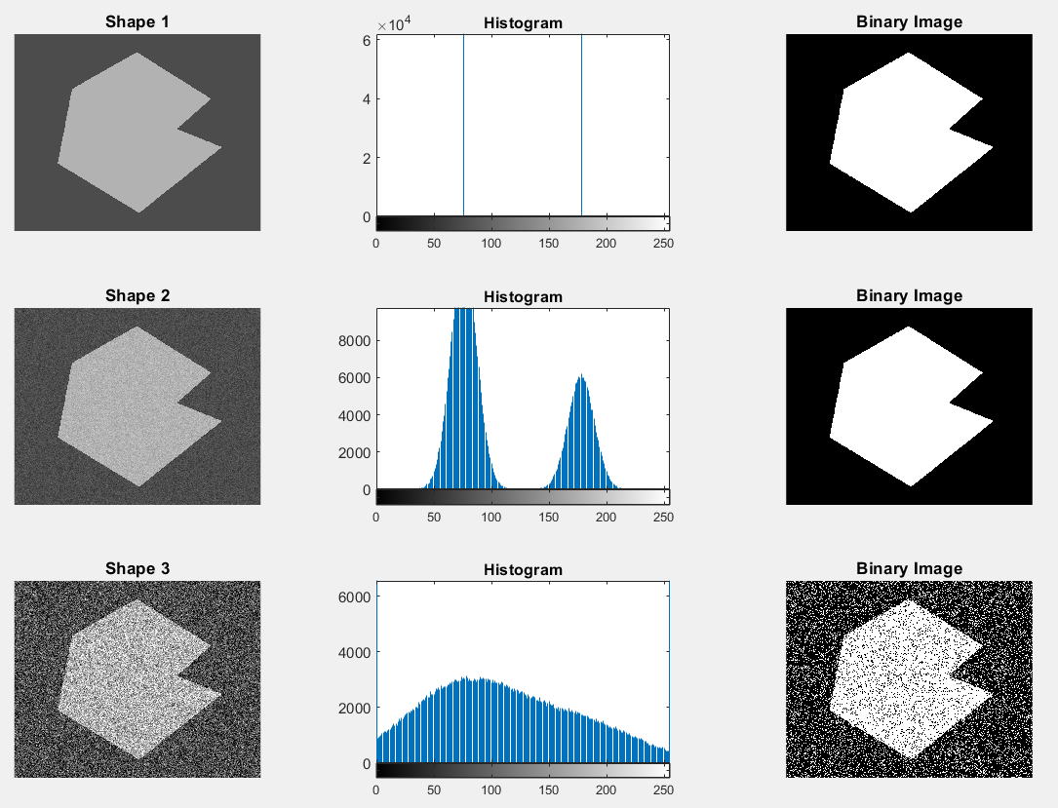

**Bin-2. Automatic binarization methods**

coins_image = imread('coins.png');

rice_image = imread('rice.png');

text_image = imread('text.bmp');

% Binarization using Otsu method

otsu_coins = imbinarize(coins_image, graythresh(coins_image));

otsu_rice = imbinarize(rice_image, graythresh(rice_image));

otsu_text = imbinarize(text_image, graythresh(text_image));

% Binarization using Kittler method

threshold_kittler_coins = clusterKittler(coins_image);

kittler_coins = imbinarize(coins_image, threshold_kittler_coins / 255);

threshold_kittler_rice = clusterKittler(rice_image);

kittler_rice = imbinarize(rice_image, threshold_kittler_rice / 255);

threshold_kittler_text = clusterKittler(text_image);

kittler_text = imbinarize(text_image, threshold_kittler_text / 255);

% Binarization using Yen method

threshold_yen_coins = entropyYen(coins_image);

yen_coins = imbinarize(coins_image, threshold_yen_coins / 255);

threshold_yen_rice = entropyYen(rice_image);

yen_rice = imbinarize(rice_image, threshold_yen_rice / 255);

threshold_yen_text = entropyYen(text_image);

yen_text = imbinarize(text_image, threshold_yen_text / 255);

% Display

figure;

% Coins image

subplot(3, 4, 1);

imshow(coins_image);

title('Original Coins');

subplot(3, 4, 2);

imshow(otsu_coins);

title('Otsu Binarization');

subplot(3, 4, 3);

imshow(kittler_coins);

title('Kittler Binarization');

subplot(3, 4, 4);

imshow(yen_coins);

title('Yen Binarization');

% Rice image

subplot(3, 4, 5);

imshow(rice_image);

title('Original Rice');

subplot(3, 4, 6);

imshow(otsu_rice);

title('Otsu Binarization');

subplot(3, 4, 7);

imshow(kittler_rice);

title('Kittler Binarization');

subplot(3, 4, 8);

imshow(yen_rice);

title('Yen Binarization');

% Text image

subplot(3, 4, 9);

imshow(text_image);

title('Original Text');

subplot(3, 4, 10);

imshow(otsu_text);

title('Otsu Binarization');

subplot(3, 4, 11);

imshow(kittler_text);

title('Kittler Binarization');

subplot(3, 4, 12);

imshow(yen_text);

title('Yen Binarization');

**Result of the code:**

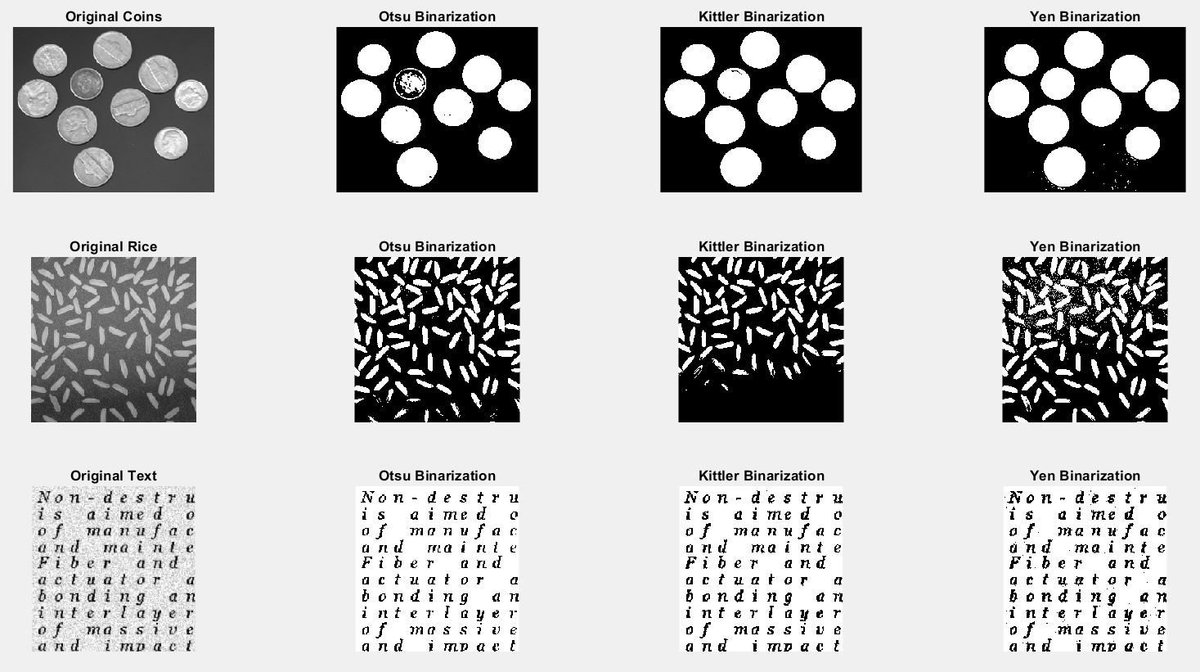

**Bin-3. Adaptive threshold**

coins_grad_image = imread('coins_grad.png');

figure;

subplot(2, 3, 1);

imshow(coins_grad_image);

title('Original Image');

subplot(2, 3, 2);

imhist(coins_grad_image);

title('Histogram');

manual_threshold = 100;

manual_binary_image = imbinarize(coins_grad_image, manual_threshold / 255);

% Otsu, Kittler, and Yen binarization

otsu_binary_image = imbinarize(coins_grad_image, graythresh(coins_grad_image));

kittler_threshold = clusterKittler(coins_grad_image);

kittler_binary_image = imbinarize(coins_grad_image, kittler_threshold / 255);

yen_threshold = entropyYen(coins_grad_image);

yen_binary_image = imbinarize(coins_grad_image, yen_threshold / 255);

% Display

subplot(2, 3, 3);

imshow(manual_binary_image);

title('Manual Binarization');

subplot(2, 3, 4);

imshow(otsu_binary_image);

title('Otsu Binarization');

subplot(2, 3, 5);

imshow(kittler_binary_image);

title('Kittler Binarization');

subplot(2, 3, 6);

imshow(yen_binary_image);

title('Yen Binarization');

adaptive_threshold = adaptthresh(coins_grad_image, 'NeighborhoodSize', 21, 'Statistic', 'Mean');

adaptive_binary_image = imbinarize(coins_grad_image, adaptive_threshold);

% Display

figure;

subplot(1, 3, 1);

imshow(adaptive_threshold);

title('Adaptive Threshold');

filled_image = imfill(adaptive_binary_image, 'holes');

opened_image = imopen(filled_image, strel('disk', 5));

subplot(1, 3, 2);

imshow(filled_image);

title('Filled Image');

subplot(1, 3, 3);

imshow(opened_image);

title('Corrected Image');

**Result of the code:**

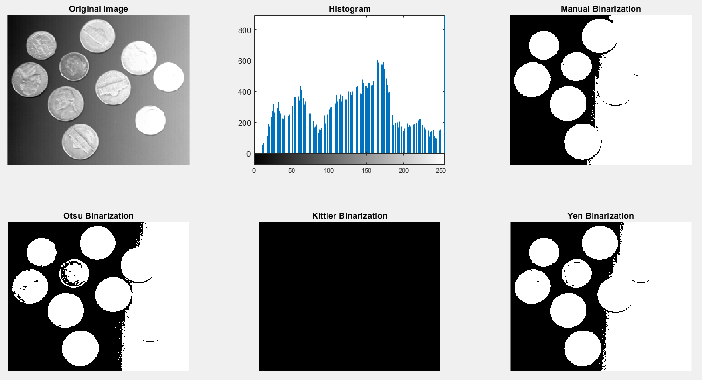

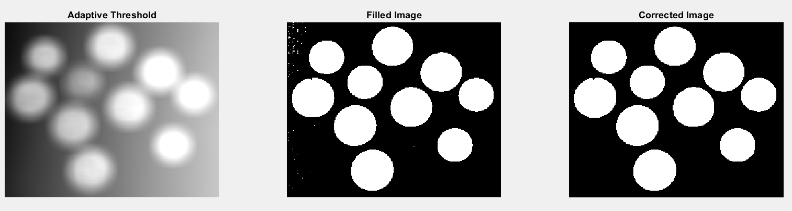

**Bin-4. Binarization with two thresholds**

bart_image = imread('bart.bmp');

figure;

subplot(2, 3, 1);

imshow(bart_image);

title('Original Image');

subplot(2, 3, 2);

imhist(bart_image);

title('Histogram');

lower_threshold = 130;

upper_threshold = 190;

binary_image = (bart_image > lower_threshold) & (bart_image < upper_threshold);

subplot(2, 3, 3);

imshow(binary_image);

title('Binarized Image');

skin_color_image = bart_image;

skin_color_image(~binary_image) = 0;

subplot(2, 3, [4, 5, 6]);

imshow(skin_color_image);

title('Skin Color Areas');

**Result of the code:**

